Solution for Chapter 8

- Each column address strobe causes 8 × 4 = 32 bytes o be transferred.
(a) Latency = 5 clock cycles or 12.5 ns
Total time = 5 + 8 = 13 clock cycles, or 32.5 ns.

(b) A second column strobe is needed to transfer the second burst of 32 bytes. Therefore:
Latency = 5 clock cycles or 12.5 ns
Total time = 5 + 8 + 2 + 8 = 23 clock cycles, or 57.5 ns.

- A 16M module can be structured as 16 rows, each containing eight 1M × 4 chips. A 24-bit address is required. Address lines A_{19~0} should be connected to all chips. Address lines A_{23~20} should be connected to a 4-bit decoder to select one of the 16 rows.

- Each block contains 128 bytes, thus requiring a 7-bit Word ﬁeld. There are 16 sets, requiring a 4-bit Set ﬁeld. The remaining 21 bits of the address constitute the tag ﬁeld.

- For the first loop, the contents of the cache are as indicated in Figures 8.21 through 8.23. For the second loop, they are as follows.
  - Direct-mapped cache
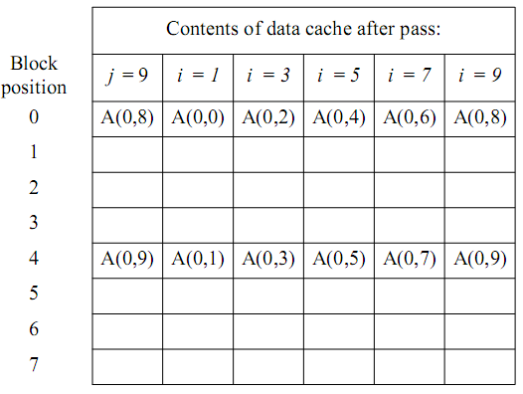

  - Associative-mapped cache
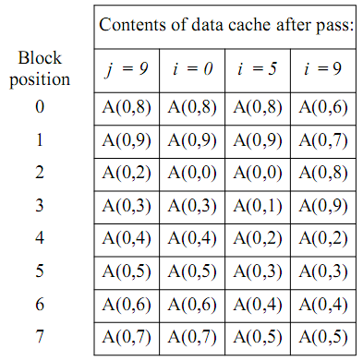
  - Set-associative-mapped cache
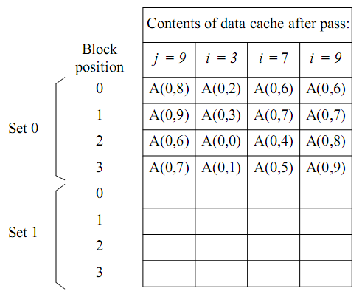

In all 3 cases, all elements are overwritten before they are used in the second loop. This suggests that the LRU algorithm may not lead to good performance if used with arrays that do not fit into the cache. Performance can be improved by introducing some randomness in the replacement algorithm.

- The two least-significant bits of an address, A₁₋₀, specify a byte within a 32-bit word. For a direct-mapped cache, bits A₄₋₂ specify the block position in the cache. For a set-associative-mapped cache, bit A₂ specifies the set.
- Direct-mapped cache
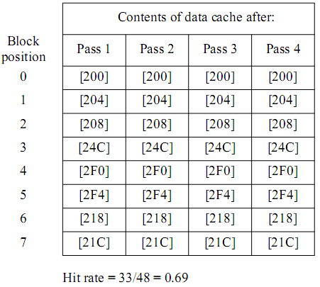

- Associative-mapped cache
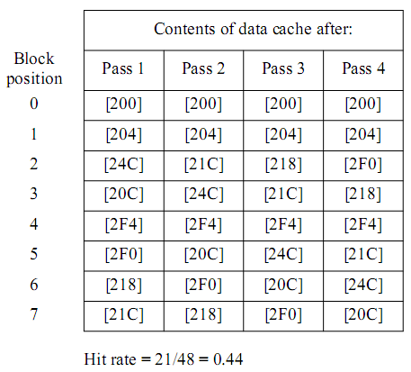

- Set-associative-mapped cache
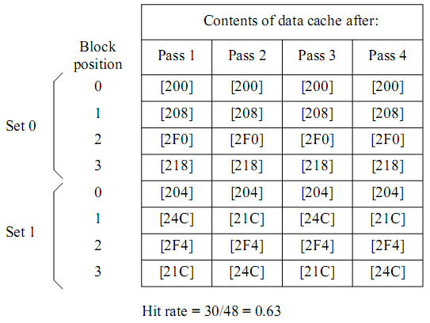

- The two least-signiﬁcant bits of an address, A_{1~0}, specify a byte within a 32-bit word. For a direct-mapped cache, bits A_{4~3} specify the block position. For a set-associative-mapped cache, bit A₃ speciﬁes the set.
    - Direct-mapped cache
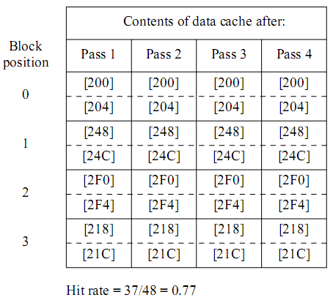

    - Associative-mapped cache
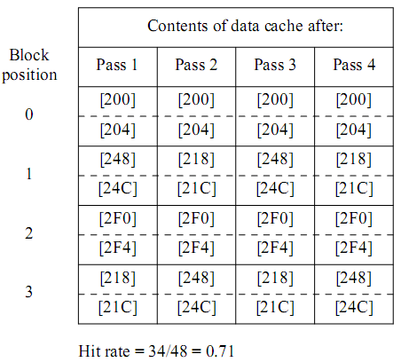

    - Set-associative-mapped cache
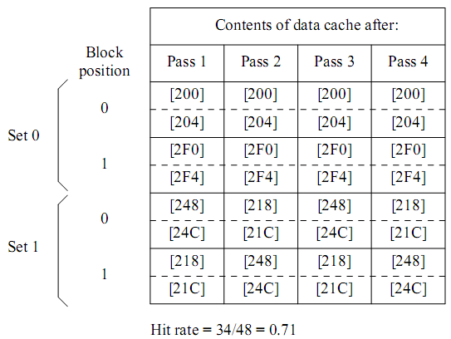

- The maximum number of bytes that can be stored on this disk is 24×14000×400×512 = 68.8×10⁹ bytes.

- The data transfer rate is (400×512×7200)/60 = 24.58×10⁶ bytes/s.

- We need 9 bits to identify a sector, 14 bits for a track, and 5 bits for a surface. Thus, using a 32-bit word b₃₁…b₀, a possible scheme is to use bits b_{8~0} for sector, b_{22~9} for track, and b_{27~23} for surface identification. Bits b₃₁₋₂₈ bits would not be used.

